|  |  |
| --- | --- |
| *school-learn-study-hat-graduate-512.png* | ***Study*** |

Read Chapter 5, section 5.1, 5.3, 5.5, 5.6, 5.7 and 5.10 of “How to Think Like a Computer Scientist: Learning with Python 3”:

<http://www.ict.ru.ac.za/Resources/cspw/thinkcspy3/thinkcspy3.pdf>

And then answer the following questions:

1. What is Boolean? Write down 3 different expression that results a Boolean type (i.e. 5 == 6)
2. What is a flow chart? Draw flow chart for the following code snippet: (you can draw on a paper, take a picture of it)

if name == “Anh Quan":

print(“Hand some")

elif name == “Minh Duc":

even\_more\_handsome = True

else:

webbrowser.open(“<https://www.youtube.com/watch?v=04854XqcfCY>”)

1. What is nested conditionals? Write a piece of code that uses nested conditionals

|  |  |
| --- | --- |
| *http://www.bestappsforkids.com/wp-content/uploads/2012/04/save-turtle.png* | ***Turtle exercises*** |

Using turtle to draw the following shapes:

|  |  |
| --- | --- |
| Screen Shot 2015-12-25 at 04.41.55.png | 2.  Hi-CBUEkYGb-DOPBqc1p-_os3fG83P3OxHLgEhilkO4 |
|  |  |

|  |  |
| --- | --- |
| *6iporAnbT.jpg* | ***Serious exercises*** |

1. Write a program that asks user their height (cm) and weight (kg), and then calculate their BMI (Body Mass Index):

BMI = mass (kg) / (height(m) x height(m) )

Note: you must do the conversion from cm to m before calculation

Then based on the BMI, tell them that they are:

* Severely underweight if BMI < 16
* Underweight if BMI is between 16 and 18.5
* Normal if BMI is between 18.5 and 25
* Overweight if BMI is between 25 and 30
* Obese if BMI is more than 30

1. Write a program that
   1. Asks users enter a number n and then calculates factorial of n: (1 \* 2 \* 3 \*... \*n)
2. Print out the following patterns:
   * 1. 20 numbers, starting from 0



* + 1. Ask users to enter a number, then print n positive numbers from 0 to n-1:



* + 1. 1’s and 0’s, consecutively



* + 1. Ask users to enter a number n, then print n 1’s and 0’s in total consecutively:



* + 1. 9 x 9 numbers (multiplication table)

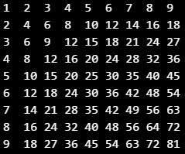

* + 1. Ask user to enter a number n, then print n x n numbers, following multiplication table pattern:

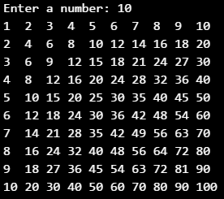

* + 1. 10 x 10 1’s and 0’s, consecutively

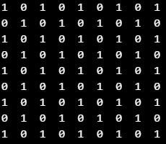

* + 1. Ask users to enter a number n, then print n x n 1’s and 0’s, consecutively

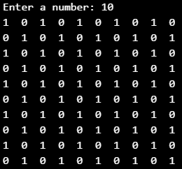

|  |  |
| --- | --- |
| system_config_boot.png | ***Tools preparation*** |

Watch the homework submission tutorial